**Year 8 Science**

**2021**

**Topic Test:**

**Periodic Table, Atomic Structure & Kinetic Theory**

**Name: _________________________ Marks: 58**

**Teacher: _______________________**

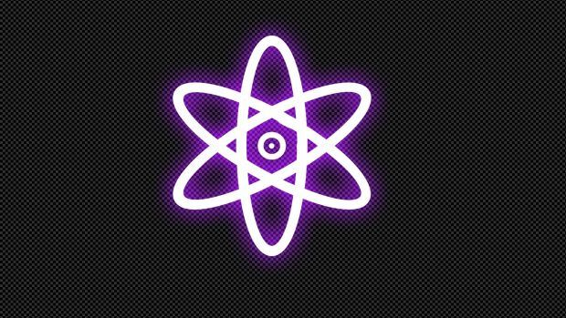

**Materials Required:**

* **Blue/black ballpoint pen**
* **Pencil**
* **Ruler**
* **Eraser**
* **Calculator**

|  |  |  |
| --- | --- | --- |
| **Section 1**  **(10)** | **Section 2**  **(48)** | **Total**  **(58)** |
|  |  |  |

**Section 1: Multiple Choice [10 Marks]**

**Circle the letter of the most correct answer for each of the statements or questions below.**

1. The Kinetic Theory of Matter states that all matter is made up of

1. stationary particles
2. substances having no regular properties
3. gases and liquids which collide
4. small moving particles

2. To be called “matter”, a substance must have

1. shape and volume
2. solid, liquid and gaseous forms
3. mass and volume
4. chemical properties

3. When a liquid is poured from one container into a different container, which of the following will happen?

1. Its volume changes
2. Its shape changes
3. Its shape and volume changes
4. Its shape and volume does not change
5. Which of the following statements about the particles in an atom is correct?

1. Protons and electrons are found in the nucleus
2. Protons and neutrons are found in the nucleus
3. Protons and neutrons are positively charged, while electrons are negative
4. Neutrons are negatively charged
5. On the Periodic Table, the horizontal rows are called

1. Periods
2. Groups
3. Elements
4. Metals
5. The atomic number of an element is equal to its number of
6. Atoms
7. Subatomic particles
8. Protons
9. Neutrons

7. Density is a measure of the total amount of mass of an object in a certain volume. Below are four 1 cm3 cubes of different metals.

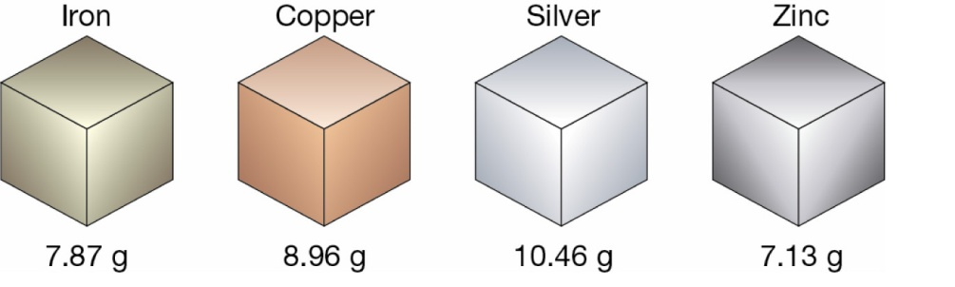

The metal with the lowest density is

1. iron
2. copper
3. silver
4. zinc

8. An object will float on top of a liquid if it is less dense than the liquid and sinks if it is more dense than the liquid. Four identical balls are dropped in four different liquids shown below. Which liquid is most dense?

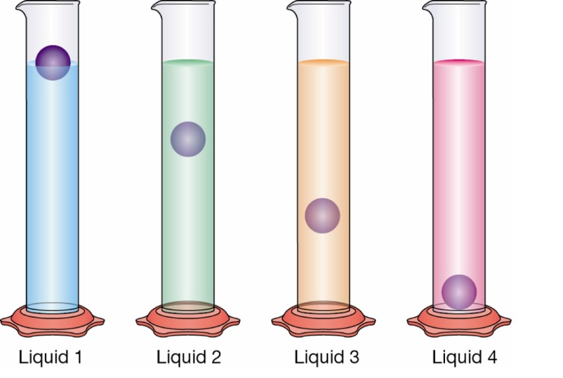

1. liquid 1
2. liquid 2
3. liquid 3
4. liquid 4
5. The atomic mass of an atom is equal to the sum of its
6. Protons and neutrons
7. Protons and electrons
8. Neutrons and electrons
9. Protons, neutrons and electrons
10. Which element from this list will have the highest atomic mass?
11. Neon
12. Oxygen
13. Sulfur
14. Helium

**End of Section 1**

**Section 2: Short Answers [48 Marks]**

**Answer ALL questions in the spaces provided below. Use a blue or black pen unless you have been asked to draw a diagram.**

**Question 11 [7 Marks]**

Select a term from those in the box below that best matches each of the statements in the table. Cross out the words as you go, as some terms will **not** be used.

|  |
| --- |
| **malleable ; solid ; periodic table ; hardness ; boiling point ; diffusion ; gas ; nucleus; brittle ; carbon dioxide; melting point; evaporation ;** |

|  |  |
| --- | --- |
| **Statement** | **Term** |
| a. a substance that undergoes sublimation |  |
| b. the temperature at which a solid changes into a liquid when heated is called its ­­­­­­­­­________________. |  |
| c. the small, dense region at the centre of the atom |  |
| d. a type of matter that has fixed volume and a definite shape |  |
| e. the natural spreading of particles from an area where they are highly concentrated to an area of low concentration |  |
| f. the state of matter in which particles have the highest kinetic energy |  |
| g. a ___________ material is one in which a thin sheet can be easily formed by hammering or rolling |  |

**Question 12 [6 Marks]**

a. Complete the table below by drawing a simple illustration to show the Particle Model of the three states of matter inside a container. You do not need to ‘fill’ the whole container. (3 marks)

|  |  |  |
| --- | --- | --- |
| **Solid** | ngle,Area,Cylinder PNG Clipart - Royalty Free SVG / PNG**Liquid** | **Gas** |
| ngle,Area,Cylinder PNG Clipart - Royalty Free SVG / PNG |  | ngle,Area,Cylinder PNG Clipart - Royalty Free SVG / PNG |

b. Briefly describe how the particles are positioned and how they move in each of these states. (3 marks)

Solid:_____________________________________________________________________________________________________________________________________________________________________________________________________

Liquid:____________________________________________________________________________________________________________________________________________________________________________________________________

Gas:______________________________________________________________________________________________________________________________________________________________________________________________________

**Question 13 [10 Marks]**

Use the formula shown below to calculate the density of each of the objects described. Set your work out clearly, showing the formula you are using for each calculation and include appropriate units with your answer.

|  |
| --- |
| **Density of an object:** **Volume of a rectangular prism:**  Density = mass ÷ Volume Volume = length x width x height |

a. (i) 25 mL of an unknown liquid was measured in a measuring cylinder. The liquid has a mass of 23.25 g. Calculate the density. (**Include working out.)** (3 marks)

Density = ______________________

(ii) Pure water has a density of 1 g/mL. Would this unknown liquid float or sink if it was added to a beaker containing pure water? (1 mark)

__________________________________________________________________

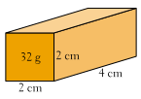

b. A rectangular block weighs 32 g. Its length,

width and height are shown on the diagram.

1. Calculate the volume of the rectangular block. **Include working out.** (3 marks)

Volume = ______________________

1. Find the density of the wooden block. **Include working out.** (3 marks)

Density = ______________________

**Question 14 [10 Marks]**

The symbols or names of several chemical elements are presented in the table below. Complete the table by filling in the correct name or symbol of each element in the appropriate space.

|  |  |
| --- | --- |
| **Symbol** | **Element Name** |
| P |  |
| Ag |  |
| B |  |
| F |  |
| K |  |
|  | Iron |
|  | Sodium |
|  | Nitrogen |
|  | Neon |
|  | Beryllium |

**Question 15 [5 Marks]**

Different types of elements are provided in the space below. Name at least one example of each element type.

a. A metalloid _______________________________________________ (1)

b. In group 1 _______________________________________________ (1)

c. A non-metal _______________________________________________ (1)

d. A metal _______________________________________________ (1)

e. In period 2 _______________________________________________ (1)

**Question 16 [3 Marks]**

Is the current model of the atom a theory or a fact? Give evidence and include an explanation of the model.

__________________________________________________________________________________________________________________________________________________

_________________________________________________________________________

_________________________________________________________________________

_________________________________________________________________________

_________________________________________________________________________

_________________________________________________________________________

_________________________________________________________________________

_________________________________________________________________________

_________________________________________________________________________

_________________________________________________________________________

**Question 17 [7 Marks]**

Refer to the diagram of a Lithium atom, fill-in the 5 labels and complete the questions below.

a. What is the atomic number of this atom? ______________________

b. What is the mass number of this atom? ______________________

**End of Test**